
COMMUNICATION PROCEDURE
Ensuring every message moves top to bottom, across the leads, and bottom to top
Field | Detail
Procedure Number | EA-COMM-PROC-01
Procedure Title | Communication Procedure
Version | 2.3
Effective Date | 13-Sep-2026

Document Approval
Prepared By — Designation  Operations Manager | Approved By — Designation  Chief Executive Officer
Name | Name
Signature | Signature
Date | Date

This procedure is binding on all staff involved in Elite Academy's communication flow. Signature by the Chief Executive Officer above authorizes this version for implementation.

This procedure is the master communication reference for Elite Academy. It works alongside the "How We Work Together" playbook (EA-COMM-PLAY-01): that document describes team culture and handoffs; this one guarantees the mechanics — who sends what, to whom, how often, and how receipt is confirmed — in all three directions. The remaining open decisions are tracked separately in the Open Items document (EA-COMM-OPEN-01), not in this procedure. See Appendix A for the full organization chart.

1. Purpose
To make sure no message is lost between Dakhil and any member of staff — whether it travels down from leadership, across between the four function leads, or up from the floor — by giving every communication a defined sender, receiver, channel, frequency, and confirmation step.

2. Scope
This procedure covers all recurring communication between the following levels:
- Level 1 — Dakhil (Direction & Alignment)
- Level 2 — Function leads: Abdullah (Training), Nasser (Operations), Maryam (Marketing), Saud (Systems & IT)
- Level 3 — Staff and branch teams: Carlos, Ahmed, Verna, Tareq, Roaa, Ayaa, and instructors
It does not replace the specific handoffs already defined in the "How We Work Together" playbook — it guarantees those handoffs, and every other cross-level message, actually complete. See Appendix A for the full organization chart, including Roaa's dual coaching/operations role.

3. The Three Directions
Every message at Elite Academy moves in one of three directions. Each has its own risk if it breaks down, so each gets its own rule:
Direction | Risk if it breaks | Guarantee
Downward (top → bottom) | Staff act on outdated or missing direction | Every decision from Dakhil reaches every affected staff member within a set time, with confirmation it was received.
Lateral (across the leads) | Teams duplicate work or contradict each other | Every cross-functional handoff has a named sender and receiver who confirms receipt before work proceeds.
Upward (bottom → top) | Leadership is blind to real conditions on the floor | Every lead reports up on a fixed cadence, and urgent issues escalate immediately, not on the next scheduled report.

4. Downward Communication — Top to Bottom
Direction, decisions, and policy changes originate with Dakhil or with a function lead acting on Dakhil's behalf, and must reach every affected person, not just the next level down.

4.1 Dakhil to Each Lead
The same vision and direction reaches every function, addressed individually so no lead is assumed to have heard it secondhand. This runs on two channels: a monthly standing meeting for strategic direction, and email in between for anything that can't wait a month.
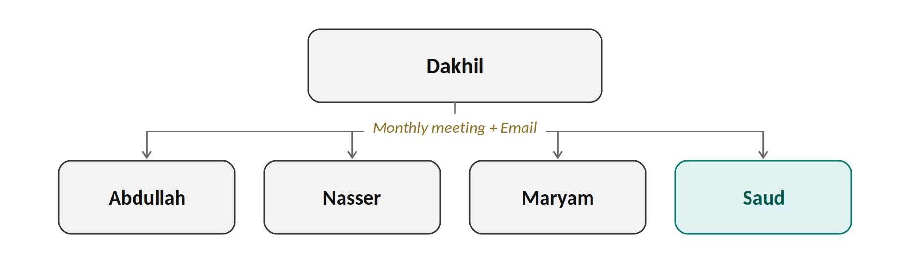

4.1.1 Monthly Standing Sync
From → To | What Moves | Channel / Frequency | Confirmation
Dakhil → Abdullah (Training) | Vision, strategic direction, and any decision affecting training programs. | Standing leads meeting, monthly. | Abdullah acknowledges in the meeting minutes.
Dakhil → Nasser (Operations) | Vision, strategic direction, and any decision affecting operations, sales, or branches. | Standing leads meeting, monthly. | Nasser acknowledges in the meeting minutes.
Dakhil → Maryam (Marketing) | Vision, strategic direction, and any decision affecting marketing or messaging. | Standing leads meeting, monthly. | Maryam acknowledges in the meeting minutes.
Dakhil → Saud (Systems & IT) | Vision, strategic direction, and any decision affecting systems or tools. | Standing leads meeting, monthly. | Saud acknowledges in the meeting minutes.
Dakhil / Operations Manager → any lead | Policy or procedure changes. | Written memo + verbal briefing, as issued. | Lead signs off or gives a logged verbal confirmation.

4.1.2 Email — Between Meetings
A month is too long to sit on a time-sensitive decision, so email carries anything that comes up between standing meetings. This is not a replacement for the monthly sync — it's what keeps the gap between meetings from becoming a communication gap.
From → To | What Moves | Channel | Confirmation
Dakhil / Management → all 4 leads | Any decision, update, or direction issued between monthly meetings. | Email. | Each lead replies to confirm receipt, then forwards the same email — not a paraphrase — to their subordinates (see Section 4.2).

4.2 Each Lead to Their Subordinates
Each lead cascades what they receive from Dakhil to their own team within 2 business days, and confirms the cascade is complete back to the source. When the direction arrived by email (Section 4.1.2), the lead forwards that same email — or relays its exact content — to their subordinates, rather than summarizing it secondhand. A lead may also use a phone call or a phone message (SMS/WhatsApp) to reach a subordinate, whichever is fastest — what matters is that the confirmation below still happens. This applies the same "accept the handoff before we let go" standard used in the playbook to downward communication, not just peer handoffs.
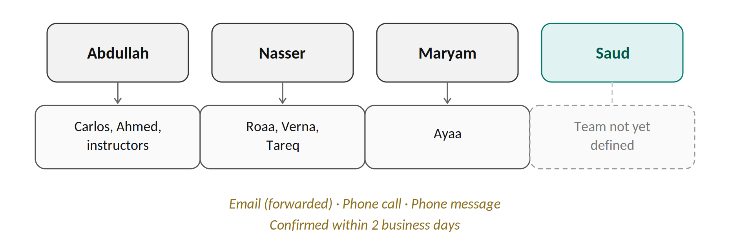
From → To | What Moves | Confirmation
Abdullah → Carlos, Ahmed, instructors | Training direction, program updates, and any decision from Dakhil affecting training. | Verbal confirmation, logged by Abdullah.
Abdullah → Roaa (coaching instructions) | Coaching direction and schedule. Also copied to Nasser per Section 5.3. | Roaa confirms; copy sent to Nasser.
Nasser → Verna, Tareq | Operations direction, bookings, and member-process updates. | Verbal confirmation, logged by Nasser.
Nasser → Roaa (Operations instructions) | Operations tasks and priorities. Also visible to Abdullah if it affects coaching. | Roaa confirms; Abdullah notified if relevant.
Maryam → Ayaa | Marketing strategy and campaign direction. | Ayaa confirms implementation.
Saud → his team | Not yet applicable — no subordinates defined under Systems & IT yet. | To be added once the function's scope and team are confirmed.
Confirmed: 2 working days is the cascade window for downward communication.

5. Lateral Communication — Across the Leads
The four function leads coordinate directly with each other so that Training, Operations, Marketing, and Systems & IT move as one system, not four separate departments.

5.1 Standing Cross-Functional Sync
All four leads and Dakhil hold a monthly management meeting (as established in the Meeting #3 / Management Meeting notes, now on the same monthly cadence as Section 4.1.1) to review the month across all four functions and translate decisions into the org chart and procedures. Between meetings, any urgent cross-functional item is coordinated directly between the relevant leads by email, phone call, or phone message (SMS/WhatsApp) — whichever reaches the other lead fastest. It does not wait for the next standing meeting.

5.2 Handoffs Between Leads
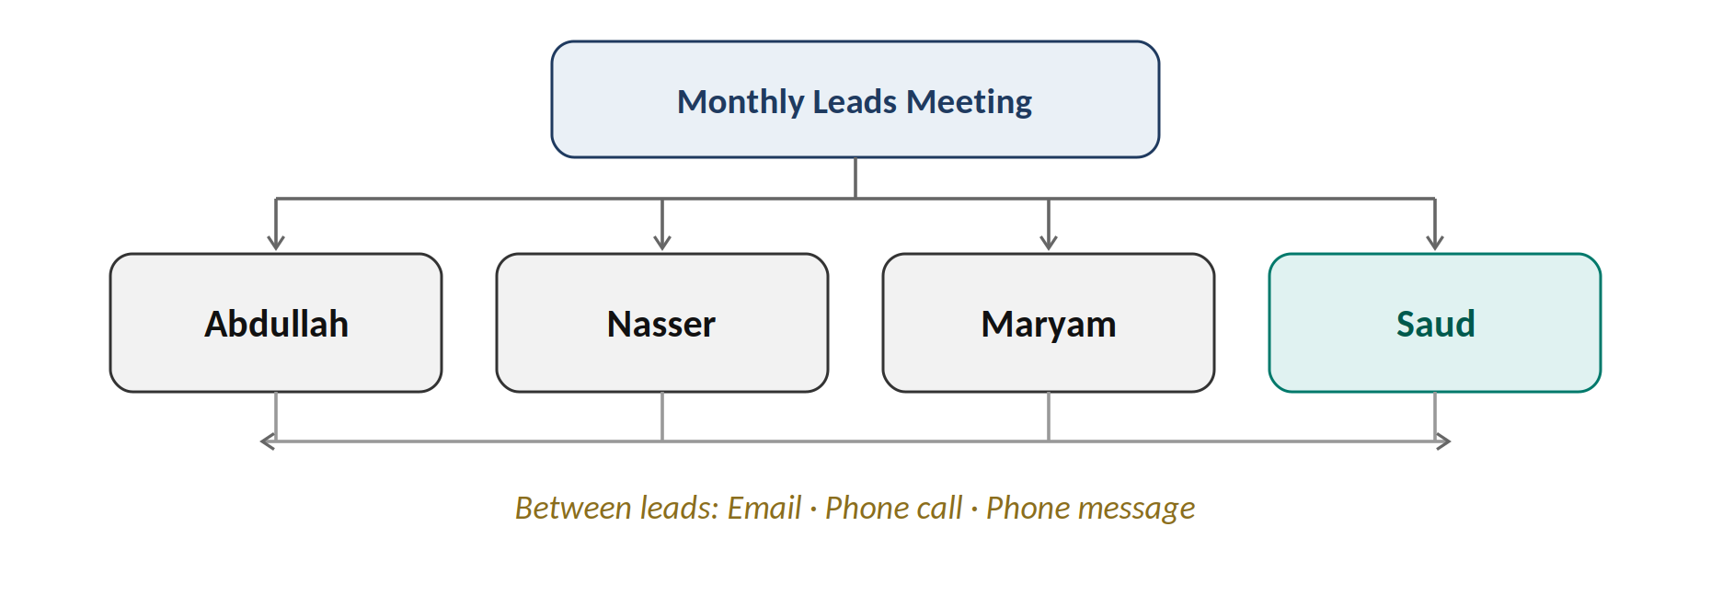
Every recurring handoff between the four leads, with the confirmation step that closes it — the content of the first six rows comes from the playbook, Section 3; the last two are new since Systems & IT was added. Any of these can happen by email, phone call, or phone message (SMS/WhatsApp), whichever gets the information to the receiving lead fastest — the confirmation step is what matters, not the channel used to get there:
From → To | What Moves | Confirmation
Abdullah (Training) → Maryam (Marketing) | Program knowledge and real progress stories. | Maryam confirms receipt and logs it for the next content cycle.
Maryam (Marketing) → Abdullah (Training) | Aligning the marketing message with what is actually taught. | Abdullah reviews and confirms the message is accurate.
Maryam (Marketing) → Nasser (Operations) | Campaigns → leads. | Nasser confirms the leads are logged in SAQR.
Nasser (Operations) → Maryam (Marketing) | Conversion results → better campaigns; Tareq's class photos → Ayaa. | Maryam confirms receipt and usage.
Abdullah (Training) → Nasser (Operations) | Attendance, progress, and concerns. | Nasser confirms the update is logged.
Nasser (Operations) → Abdullah (Training) | Bookings and member processes. | Abdullah confirms the training schedule is updated.
Any lead → Saud (Systems & IT) | Requests for new tools, system changes, or technical support. | Saud logs the request and confirms a timeline before starting.
Saud (Systems & IT) → affected lead(s) | Notice before any system or tool change that affects their team. | Affected lead confirms awareness before the change goes live.

5.3 Roaa's Dual Line
Roaa reports to Nasser (Operations) and also coaches under Abdullah (Training). To prevent conflicting instructions:
- Any instruction Abdullah gives Roaa in her coaching capacity is also logged or copied to Nasser.
- Any instruction Nasser gives Roaa in her Operations capacity is also visible to Abdullah if it affects her coaching schedule.
TO CONFIRM — the exact mechanism (email cc, a shared log, or a brief weekly note) for keeping both leads visible on Roaa's instructions should be picked by Nasser and Abdullah together.

6. Upward Communication — Bottom to Top
Information from the floor must reach leadership reliably, on two speeds: routine (scheduled) and urgent (immediate).

6.1 Routine Reporting
Routine reporting runs on the same two-channel pattern as the downward direction: a monthly report for the full picture, and email in between for anything that shouldn't wait a month.
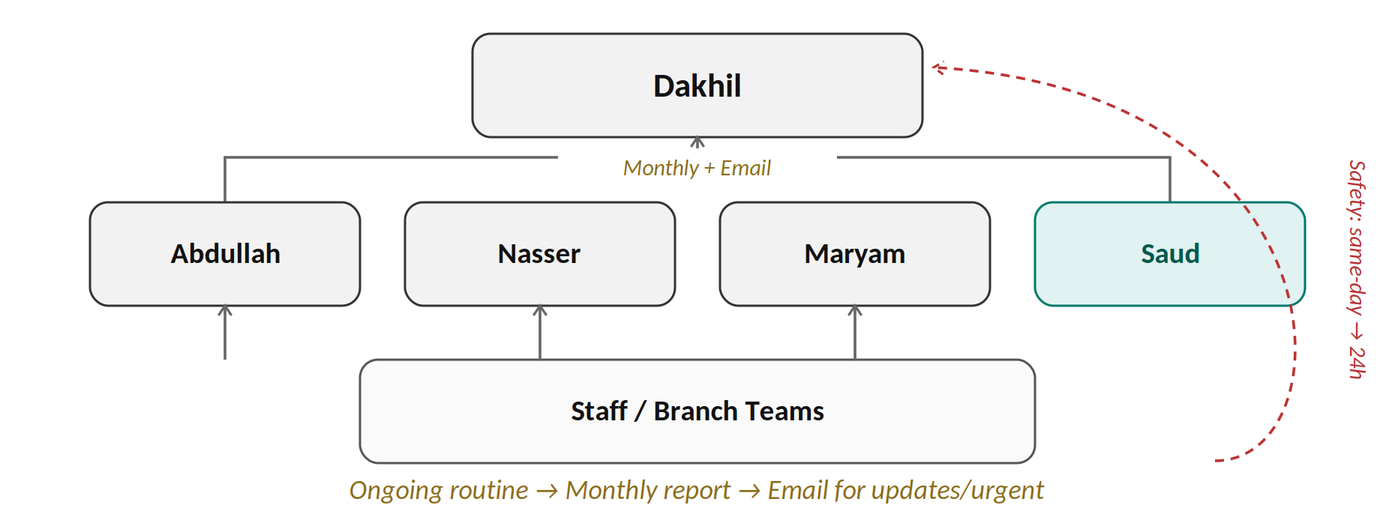

6.1.1 Monthly Reporting
From → To | What Moves | Frequency
Staff → their function lead | Attendance, progress, bookings, routine concerns (per playbook Sections 3 & 5). | Ongoing / per class or shift.
Abdullah → Dakhil | Summary of attendance trends and unresolved concerns. | Monthly.
Nasser → Dakhil | Summary of leads, conversion, and retention. | Monthly.
Maryam → Dakhil | Summary of campaign results and community growth. | Monthly.
Saud → Dakhil | Summary of systems/IT status and any open requests. | Cadence to be confirmed once scope is defined.

6.1.2 Email — Between Reports
A month is too long to sit on an update, an issue, or anything urgent, so email carries those in the gap between monthly reports — the same principle used for downward communication in Section 4.1.2.
From → To | What Moves | Channel | Confirmation
Any lead → Dakhil | Updates, issues, or other urgent matters that arise between monthly reports. | Email. | Dakhil (or the Operations Manager on Dakhil's behalf) acknowledges receipt and logs it.
Safety or conduct concerns always follow the faster escalation path below, regardless of this email channel.

6.2 Urgent Escalation
Safety or conduct concerns do not wait for the monthly cycle. This follows the escalation path already set in the playbook, Section 6:
- Same-day: any staff member raises a safety or conduct issue to their function lead.
- Immediately: the function lead names an owner and logs the concern.
- Within 24 hours: anything involving member safety or a possible removal decision reaches Dakhil directly.

6.3 A Channel Beyond the Direct Lead
So that a message never dead-ends with one person, staff have a way to raise something with Dakhil directly if it isn't being addressed at the lead level.
Confirmed: if a lead is not answering or not acting on a message, the staff member calls Dakhil directly by phone.

7. Closing the Loop — One Shared Standard
Every direction in this procedure runs on the same underlying rule, already stated in the playbook: the next person accepts the message before the sender lets go of it. Concretely, that means:
- Every message names who sent it and who must confirm receiving it.
- Confirmation is never assumed from silence — it is a reply, a signature, a logged entry, or a verbal acknowledgment someone recorded.
- If confirmation doesn't come within the stated timeframe, the sender follows up rather than assuming the message landed.

8. Record Keeping
Meeting minutes, cascade confirmations, and escalation logs are kept by the Operations Manager, who owns this procedure. Leads keep their own team-level confirmations (sign-offs, verbal-confirmation logs) per Section 4.1.
Confirmed: all communication records are stored on the shared drive.

Appendix A — Organization Chart
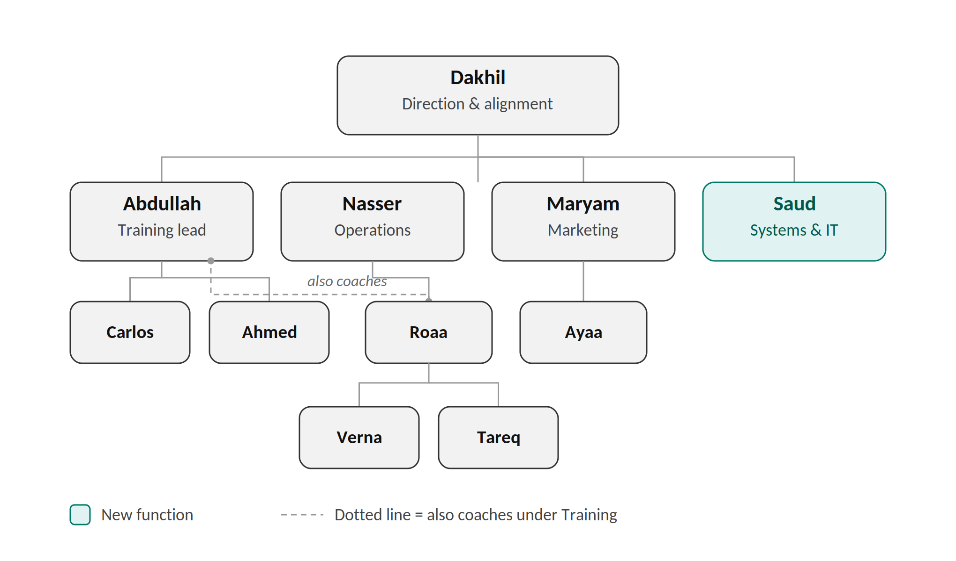
Carlos leads grappling and Ahmed leads striking under Abdullah, with all instructors reporting to him. Roaa reports to Nasser in Operations, sitting above Verna (Promenade, Hawalli) and Tareq (Bedaya), and also coaches under Abdullah in Training — shown by the dotted line. Ayaa implements marketing strategy under Maryam. Saud (highlighted) is the newly added Systems & IT function; his team, if any, is not yet defined.

